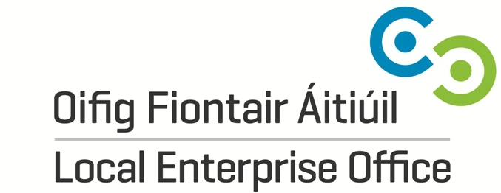

Building Craft & Design Enterprise
Premium package of support tailored for designer-makers to boost, product development, export potential, employment and commerciality of websites through bespoke workshops, mentoring and an accompanied retail/trade research visit to London.

Closing Date: Tuesday 25th June 2019 @ 5pm
Please attach your Curriculum Vitae (max. 2 pages) and 3 digital images of your work.
Applications to be sent via email: catherine.hennessy@leo.kilkennycoco.ie

For further information contact:
Catherine Hennessy
Local Enterprise Office Kilkenny
42 Parliament Street, Kilkenny
056-7752662

Applicant Details

Name of Applicant

Craft & Design Discipline

Current Address

PPS/ CRO number Phone

Email Website

Are you registered with the Crafts Council of Ireland? Yes No

How long have you been in your current business?

Please note to take part you must be in business a minimum of 18 months and be working on your business full time.

Describe your product range and your target market: (max. 300 words)

How do you feel the Building Craft & Design Enterprise Programme assist you in developing your business? (max. 300 words)

Please return by email by 25 June 2019 to the Local Enterprise Office

