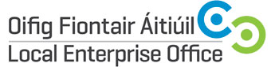

IQFA Meet the Buyer Event 23rd May 2019

Expression of Interest

Contact Name:

Company Name and Address:
Landline/mobile Telephone:
E-mail Address:
Website Address:
Type of Product:

Short Bio of the Business

One print quality picture is attached | Yes □ No□

Signature: Date:

__________________________________________ ________________

Please note cost of participation at this event is €100. Businesses will be invoiced after successful selection.
Closing date for receipt of expression of interest accompanied by print quality picture is 5pm on Friday, 5th April to info@leo.leitrimcoco.ie



