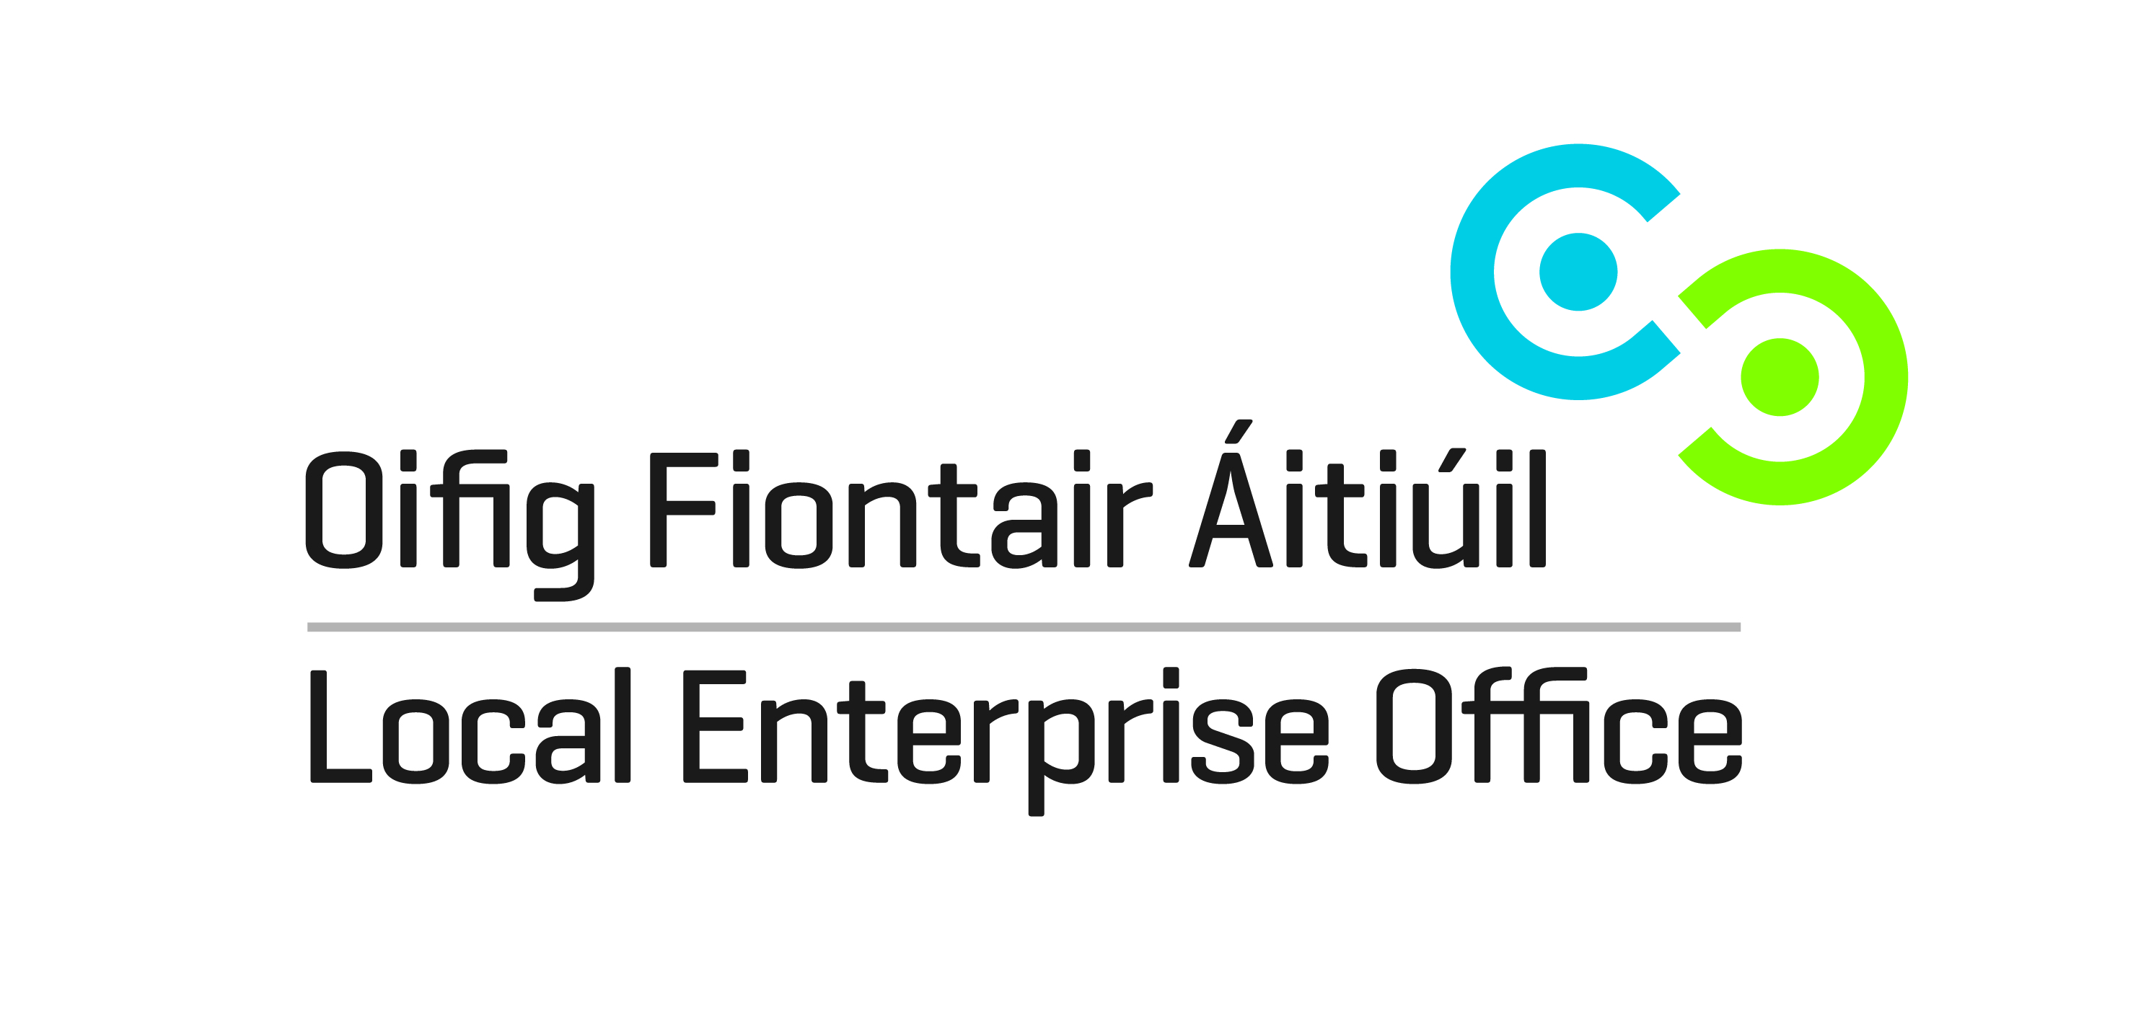
SHOWCASE 2018
RDS, Ballsbridge, Dublin 4.
21st – 24th January 2018
EXPRESSION OF INTEREST / APPLICATION TO EXHIBIT
COMPANY NAME:
CONTACT NAME:
CONTACT MOBILE NUMBER:
EMAIL:
ADDRESS:

PRODUCT DETAIL:

NOTE:
Successful applicants will be required to pay the relevant subsidised cost (TBC) by Friday 14th July 2017 or their space will be re-allocated to others on the waiting list.
Please send completed form to nbaynes@sdublincoco.ie

