ABC Packaging Limited

Business Proposal

“An Assessment of the Business Potential of high quality presentation/packaging boxes in the Irish Market”

Promotors/Directors’ Details

Names | Thomas Murphy and John Swift
Address | 10 Street Road, Waterford
Telephone | 051 000000
Fax | 051 000000
Mobile | 086 000000
Email | tm@abc.ie
Web | www.abc.ie
Date | August 2007

“This business plan is confidential and is intended only for the person or entity to which it is addressed. It shall not be divulged to a third party, without the authors’ consent in writing”.

Table of Contents
1.0 Executive Summary………………………………………………………………………... .. 3

2.0 Business Background of Promoters……………………………………………………… .. 4

2.1 Business Description & Purpose…………………………………………………… .. 4

3.0 Legal Status & Licence…………………………………………………………………….. .. 5

4.0 Management & Organisational Structure………………………………………………... .. 5

5.0 Market Analysis…………………………………………………………………………….. .. 6

5.1 Market Demand……………………………………………………………………….. 6
5.2 Rigid Box Supply…………………………………………………………………….. .. 6
5.3 Target Market………………………………………………………………………… .. 6
5.4 Competitive Environment…………………………………………………………… .. 7

6.0 Product Proposition………………………………………………………………………… .. 8

6.1 Pricing Strategy……………………………………………………………………….. 8
6.2 Channels of Distribution…………………………………………………………….. .. 8
6.3 Summary SWOT Analysis…………………………………………………………..... 9

7.0 Sales & Marketing Strategy……………………………………………………………….. .. 10

7.1 Sales Management………………………………………………………………….. .. 10
7.2 Sales Forecasts……………………………………………………………………… .. 10
7.3 Advertising……………………………………………………………………………. .. 11
7.4 Personal Selling……………………………………………………………………… .. 11

8.0 Operational Plan……………………………………………………………………………. .. 12

8.1 Manufacturing Process……………………………………………………………… .. 12

9.0 Financial Plan……………………………………………………………………………….... 13

9.1 Comments on Financial Plan………………………………………………………… 13
9.2 Discussion on Cash Flow Projections….…………………………………………… 13

10.0 Financing Plan…………………………………………………………………………….. .. 14

10.1 Comments on the Financing Plan………………………………………………... .. 14
10.2 Profit & Loss Statements………………………………………………………….. .. 14

Appendices………………………………………………………………………………………... 16
Business Plan

1.0 Executive Summary
ABC Packaging Limited is jointly owned by Thomas Murphy and John Swift. The location of the business will be the Industrial Park, on the Cork Road, Waterford, which is strategically located near the ring road, thus facilitating quick access to the main Cork, Dublin, Limerick and Wexford roads.

Total working capital requirements required is €435,100 which will be funded as follows:-
- € 86,000 will be invested in to the business by the promoters (Equal Partners)
- €45,200 will be secured via successful grant aid applications
- € 393,400 of lease finance will be sought during the first two years of business

The projected profit and loss statements indicate that the business will break-even in year one and achieve profits of €55,000 in year two and €122,000 in year three.

Sensitivity analysis indicates that if the sales level fell to 75% of that forecasted in year one, the net loss for the year would be €48,000 with the cash flow remaining at a positive €44,000 at year end.

2.0 Business Background of Promoters
Thomas Murphy (confirm) has recently returned to Ireland having lived in the United States for fifteen years. He was employed in various functions for ten years with a leading manufacturer of rigid boxes. His most recent position was that of Plant Manager. His company were suppliers to the software, CD-ROM etc. sectors. This has given him considerable experience in the manufacturing of these products. Mr. Murphy (confirm) re-located to Ireland due to family and personal reasons, and having considered a number of employment options, decided to start up the business. Research undertaken has demonstrated that there is no source of rigid box manufacturing in Ireland; currently, users import their rigid box requirements from suppliers in the UK and mainland Europe.

John Swift (confirm) was made redundant during the restructuring of a multi-national, and has over fifteen years experience in Sales Management, coupled with a very good understanding of finance. He qualifies under the Seed Capital Scheme, which, along with his redundancy payment, will provide his equity in the company.

The key business goal of the Promoters/directors is to become the preferred supplier of rigid boxes in Ireland. Once this goal is realised, the promoters plan to assess the potential of exporting initially to the U.K., and then into mainland Europe.

2.1 Business Description and Purpose
The product range will comprise of high quality rigid boxes; over the last number of years, rigid boxes have been replacing folding or softer type boxes for packaging purposes. The product will be marketed primarily to the board games, software, CD-ROM, greeting card, table mats and prestige drinks markets. These markets rely heavily on strong packaging to create awareness, enhancing customer interest and ultimately sales. This points to a real opportunity for ABC Packaging Limited’s products.

Improved technology and production methods have made the rigid box a viable alternative to a folded box; this will serve to enhance the marketing process of several potential customers. The scope for the provision of a ‘pack-off facility’ further improves the range of services which ABC Packaging Limited can offer its potential customers.

3.0 Legal Status & Licence
It is proposed to operate the business through the legal entity of a limited liability company called ABC Packaging Limited. The amount of shares to be issued will be determined by the requirements relating to state support, borrowing facility and investment.

There are no specific licences required to operate the business. A Health and Safety Statement will be prepared prior to commencement of operations; the promoters will seek the assistance of a consultant in this area.

Since quality assurance will be paramount to ensure customer confidence, the costs of achieving accreditation to ISO9002 are included in the estimates. It is intended to obtain accreditation as early as possible.

Preliminary discussions with the Planning Office have indicated that there is no need to apply for planning approval. This is due to the fact that the proposed premises are located in an Industrial Park.

4.0 Management & Organisational Structure
All aspects of the operations will be managed by the promoters for the initial three years.
There will be a requirement for two production staff, increasing to five within the first two years. These employees will be primarily in production. The administration, marketing and finance functions will be managed by the key managers i.e. the promoters.

The accountancy function will be outsourced initially. Books will be kept manually during year one, but it is intended to invest in a computerised software accountancy package (e.g. Sage) during year two.

5.0 Market Analysis
The market analysis conducted indicates that there are no other high volume suppliers of rigid boxes in Ireland. At present, companies source their requirements in the U.K. and Germany.

The rigid box supply base in Ireland is geared towards the manufacturing of low volume, hand-crafted, expensive products to service a niche market; this market requires the supply of a quality, volume fulfilment and pack-off service.

5.1 Market Demand
As indicated in the previous section, a niche market has been identified. Market research indicates the Irish market for rigid boxes is estimated to be €3.75 million annually.

ABC Packaging Limited has set its sales target at €374k in year one, increasing to €850k in year three. Year one target equates to a 10% share of the market (Refer to table 1 for full breakdown of projected sales).

There is the possibility of extending the business into the area of order fulfilment, which means on-line packing of products for customers. This will lead to efficiency, costs savings and shortened lead-time for potential customers. However, it is the director’s intention not to enter this sector in the initial three years of operation.

5.2 Rigid Box Supply
As there is no supplier of such boxes in Ireland, the primary business focus will be the supply of rigid boxes; this gives the Irish business a real competitive advantage over importers. As previously stated, potential customers are purchasing mainly from the U.K. and German, resulting in excessive lead times, high “minimum order quantities” and significant transportation costs.

5.3 Target Market
The Irish Purchasing Institute Database was used to identify the key potential customers in each market segment. The intention is to target the materials/purchasing departments in no more than four companies in each segment. The six main categories to be targeted are as follows:
- Crystal Manufacturers
- Multimedia Suppliers
- Greeting Card Companies
- Table Mat Producers
- Costume Jewellery Manufacturers
- Linen Manufacturers

The initial approach with each market will focus on the provision of rigid boxes. Once the customer relationship develops, and credibility is assured, the offer will be extended to include pack-off.

5.4 Competitive Environment
ABC Packaging Limited aim to offer a similar range of products as those offered by UK/European competitors. However, with its proximity to its customer base, ABC Technology Ltd. will be in a position to offer lower “minimum order quantities”, quicker lead times and reduced transport costs. The company will invest in the most up to date equipment, which will minimise labour costs, drive production yields and minimise unit production cost.

6.0 Product Proposition
The business will produce and supply a range of quality, low cost rigid boxes, in real time to customers in its market segments, using ‘Just in Time’ manufacturing and logistics principles. Furthermore, the company will emphasise its product quality by becoming accredited to ISO 9002 as quickly as possible (ISO 9002 is an internationally recognised quality assurance system and will engender customer confidence in the quality of our products).

6.1 Pricing Strategy
The market research completed has indicated the purchase price of the various rigid boxes in the market segments. The pricing strategy to be adopted will be to undercut these prices by 10%. The pricing strategy, coupled with the proximity to supplier and reduced order size, will present an attractive proposition to potential customers.

The manufacturing equipment to be purchased is highly automated and at least equivalent, if not better, than that used by the competition. This, along with the lower overhead base, will lead to high productivity, and low production costs. These will contribute to a very attractive selling price to the market.

6.2 Channels of Distribution
The geographic market area will be the island of Ireland. Potential customers will be sourced across all market segments, totalling twelve for the first three years.

As the product is quite technical, going direct to customers is the most effective route to market strategy. To ensure customer specification / design is fully understood, face to face sales and service is required. By offering expert advice it will be possible to identify customer needs and find solutions to offer quality product at as low a price as possible.

A summary of the internal strengths and weaknesses, coupled with the external weaknesses and threats are summarised overleaf in table 2.

  - SWOT Analysis

The SWOT Analysis succinctly captures the strengths and weaknesses of ABC Packaging Limited, and points to the opportunities and threats that the market presents.

Strengths  - Experienced employees with specialist skills  - Proximity to Customer Locations  - Reduced Order Size  - Reduced Lead Time  - High Quality Service & Products  - Low Fixed Costs | Weaknesses  - Brand Name not Established  - One-product focused
Opportunities  - Growing Market  - Offer an in-line packaging service to customers  - Advance Production of main use Items of customers to provide a quick turnaround | Threats  - New Entrant into Market  - Large Competitors  - Established Customer Relationships and Loyalty  - Economic Turndown will Reduce Sales of Crystal and Software Products

Table 2: SWOT Analysis

7.0 Sales and Marketing Strategy

7.1 Sales Management
In the early stages, the directors will be solely responsibility for sales, due to the technical nature of the product. From an operational perspective, this is feasible, due to the low number of potential customers to target in the first three years (target maximum of 12 customers).

It is the intention to recruit a sales person when the finances of the business permit. This
person will be trained in the product specifications, management philosophy and the manufacturing processes to ensure full product knowledge is acquired. This will ensure that the sales person will be in a position to fully understand customer needs and make intelligent recommendations.

7.2 Sales Forecasts
The forecasted sales are indicated in Table 1. Demand and monthly projections for the coming 3 years are contained in Appendices 2(a) and 2 (b).

Rigid Box Sales Potential V Total Potential Market
Sector | Yr1 (‘000) | Yr2 (‘000) | Yr3 (‘000) | Total Potential Market (‘000)
Crystal | €206 | €290 | €385 | €2110
Multimedia | €70 | €140 | €160 | €680
Greeting Cards | €16 | €30 | €55 | €160
Table Mats | €12 | €20 | €40 | €120
Costume Jewellery | €55 | €100 | €160 | €520
Linen | €15 | €30 | €50 | €150
Total | € 374k | € 610k | € 850k | € 3740k
% of Potential Mkt | 10% | 16.3% | 22.7%

Table 1: Forecasted Sales (Rigid Box Sales Potential V Total Potential Market)

*The demand for the product is continuous and linked to the fluctuations in sales of the customer base. However as previously stated due to proximity of the customer locations it is anticipated that orders will be repetitive and frequent.

7.3 Advertising
An overall marketing budget has been agreed to ensure the target market are made aware of the product and its unique selling points. In terms of advertising, there will be limited, but focused ads and editorial placed in a selection of relevant trade journals.

7.4 Personal Selling
The principle marketing tool that will be employed by ABC Packaging Limited will be direct and personal selling. Cold calling, comprising of telesales and customer visits, will be the main thrust of the sales effort. Sales calls will emphasise the advantages of using an Irish based supplier (including low cost production and unparalleled lead times).

8.0 Operational Plan
ABC Technology Limited will supply a range of rigid boxes to the sectors as indicated in Section 5.2.

8.1 Manufacturing Process
ABC Packaging Limited will supply a range of rigid boxes to meet the specifications and requirements of the targeted customer sectors. The manufacturing process will be guided by the philosophy of (JIT) Just in Time Manufacturing, thus ensuring the minimum amount of working capital is tied up in stock.

The machinery sourced has the capability of finishing the product to the standard requirements of each of the targeted sectors. The products will be designed to match customer requirements with the company offering attractive, functional and unique solutions. The manufacturing strategy ensures that ABC Packaging Limited act as a technical design function to its customer base, thus ensuring customer satisfaction and profitable growth.

The manufacturing equipment chosen is fully automated and requires limited labour involvement, thus ensuring a competitive unit production cost.

The bulk of the raw materials required can be sourced in Ireland from a number of different suppliers.

9.0 Financial Plan

Table 3 outlines the total funding required for the Business Venture.

Field | Projected Cost - €
Premises | 0
Fixtures/Fitting | 4,000
Office Equipment | 10,000
Tooling | 15,000
Transport | 0
Consultancy | 5,000
Printed Materials | 2,000
Auditors/Accountants | 8,000
Production Equipment | 48,700
Total Funding Required | 92,700

Table 3: Areas that will Require Financial Assistance

9.1 Comments on Financial Plan
The source, type and specification of the fully automated production equipment have been identified. It is anticipated that the cost of equipment purchased in year one will be €48,700; this will provide sufficient capacity to meet the forecasted sales in year one. It will be necessary to invest in further machinery during year two. This additional investment will cost €290,000. The equipment to be purchased is as follows:

- Rigid Box Wrapper
- Baler for Waste Reduction
- Pallet Wrapper
- Heat Sealers
- Die Cutting Pattern
- Fork Lift Truck

Other purchases include the tools necessary to die cut and fold the rigid boxes. There is no intention to invest in transport, as delivery of finished product will be outsourced. A quality brochure will be produced to assist the sales efforts.

9.2 Cash Flow Projections
The cash flow projections for year one (Refer to Appendix 1A), indicate a cash deficiency of €24,998, which is needed until such a time as lease finance is received. To counteract this, a bank overdraft facility of €30,000 will be sought, and improved credit terms will be negotiated with the main machinery supplier. During the second year of operation, a negative cash flow of €5,185 will be countered by seeking improved credit terms from the machinery suppliers (Refer to Appendix 1B).
10.0 Financing the Plan

Working Capital | Amount € | Financed by: | Amount €
Investments | € 410,100 | Lease Finance | 393,400
Working Capital | € 25,000 | Equity | 68,000
 |  | Grants | 45,200
 |  | Term Loan | 10,000
 |  | Seed Capital Scheme | 18,000
Total Capital Required: | € 435,100 | Total Finance Available: | € 626,600

Table 4: Financing Plan

10.1 Comments on the Financing Plan
The investment shown is the total required during the first two years of operation. The promoters have opened discussions with lease finance companies, as it is their intention to raise lease finance for equipment and machinery. A grant application in the amount of €45,200 will be submitted to the local County and City Enterprise Board. One of the promoters meets with criteria under the Seed Capital Scheme, and an estimated €18,000 may be available from this fund.

The promoters are making an equity investment of €68,000, and as a fall-back position, a five year term loan of €10,000 will be sought from the bank.

In the event that the full capital amount required for the expansion during the second year is not realised, the promoters will defer same until adequate finance becomes available from the internal cash flow of the business.

10.2 Profit and Loss Statements
The Profit and Loss statements for 2007 and 2008/2009 are contained in Appendices 2A and 2B respectively. ABC Packaging Limited anticipates a loss of €5,206 in the first year of operation. This is, in effect, a break-even situation. The sales forecast for the first year is based on achieving a 10% share of the Irish Market. Considering that our competitors are based outside of Ireland, this is a conservative target.

The second and third year of operation show net profits of €55,092 and €122,602 respectively. Year three sales target equals 22.7% of the available Irish Market. The business has set a target of realising a 50% share of the Irish Market by the end of the fifth year of operation. This will result in a strong business and market leadership in Ireland.

As indicated in Table 2, ABC Packaging Limited intends to expand into order fulfilment by operating an “in-line” packaging service to its customers. This will be pursued during the third year of operation, with the intention of commencing this service during year four.

Potential customers showed a high level of interest in this service. Market Research estimates that an additional sales level of €500,000 can be added by the end of the first year by offering this service.

In the event of not realising forecasts during year 2, this service can be introduced earlier than what is currently planned.

Appendices

Appendix 1A

Cash Flow Projections 2007
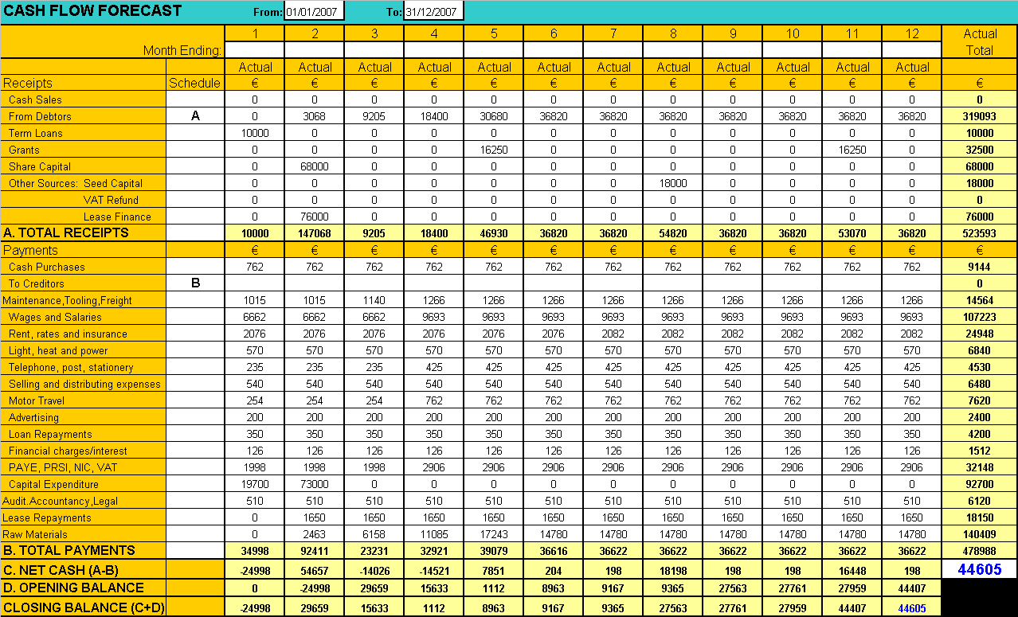

Appendix 1B

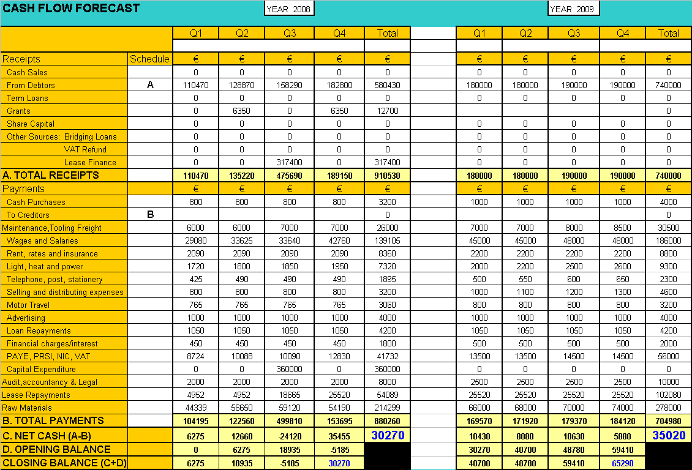
Cash Flow Forecast – 2008 & 2009
Appendix 2A

Profit and Loss Statement 2007
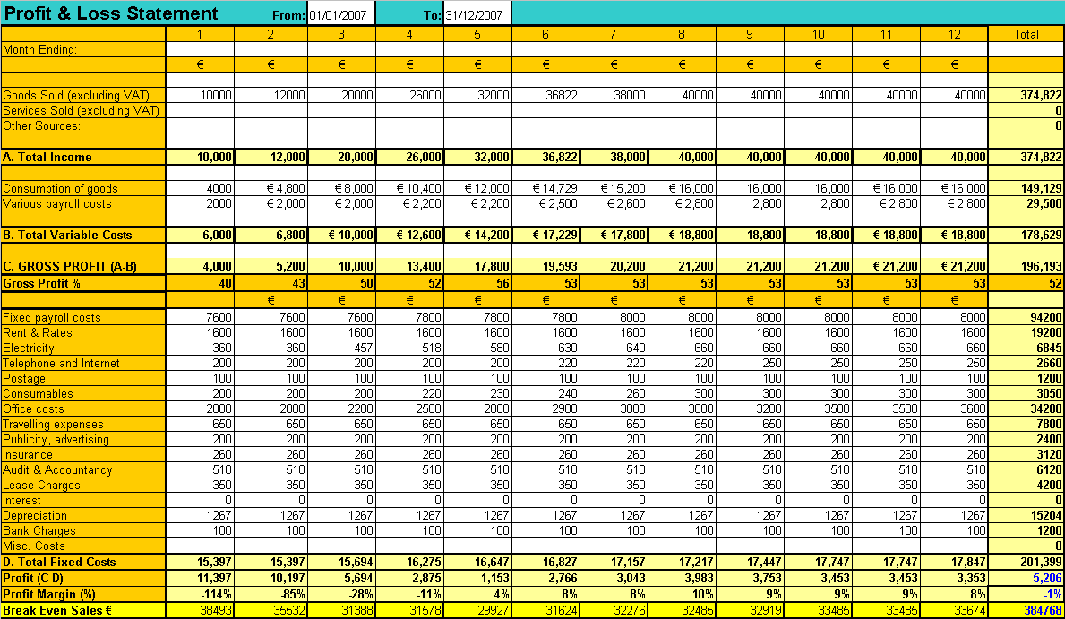
Appendix 2B

Profit and Loss Statement 2008/2009

